
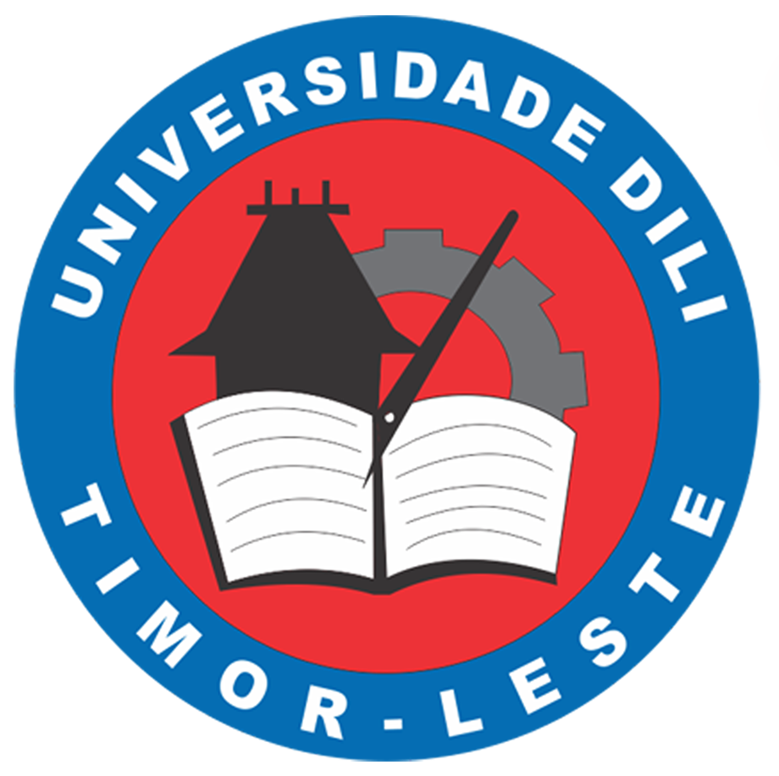

MEMORANDUM OF AGREEMENT

BETWEEN

MASTER OF LAW
UNIVERSIDADE DILI (UNDIL)
DILI, TIMOR LESTE

AND
MASTER OF LAW
UNIVERSITAS ISLAM SULTAN AGUNG (UNISSULA)
SEMARANG, INDONESIA

ON HELPING LECTURERS AND EXCHANGE OF LIBRARY ACCESS

This MEMORANDUM OF AGREEMENT (hereinafter referred to as “MoA”)
is made on the October …, 2020

BETWEEN
................................................................................................................................................................................................................................................................................................................................................................................................................................................................................................................................................................................................ and shall include its lawful representatives and permitted assigns (hereinafter referred to as “..................................................”).
AND
MASTER OF LAW UNISSULA, a master program under faculty of law in Universitas Islam Sultan Agung whose address is at Jl. Raya Kaligawe Km. 4 PO. Box. 1054/SM SEMARANG 50112, Indonesia and shall include its lawful representatives and permitted assigns (hereinafter referred to as “MIH UNISSULA”).
(.... and MIH UNISSULA hereinafter referred to singularly as “the Party” and collectively as “the Parties”)

WHEREAS
A. ...........................................................................................................................................................................................................................................................................................................................................................................................................
B. MIH UNISSULA is an established master program of law with proven research, educational abilities, and with collaborative arrangements with many counterparts to share its expertise and enhance its academic links and cooperation.
C. The Parties are desirous of entering this Memorandum of Agreement to declare their respective intentions and to establish a basis of cooperation and collaboration between the Parties upon the terms as contained herein.

NOW THIS MOA WITNESSES AS FOLLOWS:

ARTICLE 1
OBJECTIVES
The Parties, subject to the terms of this Memorandum of Agreement and the laws, rules, regulations and national policies from time to time in force in each party’s country, shall endeavour to strengthen, promote and develop international and academic co-operation between the Parties on the basis of equality and mutual benefit.

ARTICLE 2
AREAS OF COOPERATION
2.1 Both parties agree to encourage the following activities, in particular, to promote international academic cooperation in the following areas :
- helping lecturer from Magister of Law UNISSULA to teach in ...............;

- exchange of access to digital book collections in the library of the Parties;

- cooperation in any other areas as agreed to by the Parties from time to time.

2.2 For the purpose of implementing the co-operation in respect of any areas stated in paragraph 2.1 the Parties shall enter into legally binding agreements subject to terms and conditions as mutually agreed upon by the parties including clauses on “confidentiality”, “suspension”, “protection of intellectual property rights” and “settlement of disputes”.
ARTICLE 3
OBLIGATIONS AND RIGHTS
3.1 For helping lecturer activities, ....... is obliged and have rights to :
- provide all information regarding the courses and academic documents including teaching agreement or working contract and schedule;

- provide accomodation, transport, health insurance, assistance, and fees during the teaching period of the participated lecturers.

3.2 For helping lecturer activities, MIH UNISSULA is obliged and have rights to :
- send nomination letter, curriculum vitae, diplomas and other required documents of the participated lecturers;

- conduct coordination meeting with the participated lecturer to disseminate all information regarding the program before the program is executed;

- decide the number of the participated lecturer based on the expertise, availability, and financial ability.
3.3 For online library access, both parties are obliged and have rights to :
- provide open access for each party to the digital book collections in the library.

ARTICLE 4
NO AGENCY
Nothing contained herein is to be construed so as to constitute a joint venture partnership or formal business organisation of any kind between the Parties or so to constitute either party as the agent of the other.

ARTICLE 5
ENTRY INTO EFFECT AND DURATION
5.1 This Memorandum of Agreement shall become effective as of the date of signatures of both parties, or if the dates vary, then the date of the later signature.
5.2 This Memorandum of Agreement shall remain in effect for a period of FIVE (5) years.
5.3 This Memorandum of Agreement may be extended for such further period as may be agreed in writing by both parties.
5.4 If the Memorandum of Agreement is not renewed by mutual consent, the Memorandum of Agreement shall conclude at the end of the specified period, or after activities in progress have concluded.

ARTICLE 6
REVISION, VARIATION AND AMENDMENT
6.1 Either party may request in writing a revision, variation or amendment of this Memorandum of Agreement.
6.2 Any such revision, variation or amendment agreed to by the Parties shall be in writing and shall form part of this Memorandum of Agreement.
6.3 Such revision, variation or amendment shall come into force on such date as may be determined by the Parties.
6.4 Any revision, variation or amendment shall not prejudice the implementation of any project, activity or co-operation arising from or based on this Memorandum of Agreement before or up to the date of such revision, variation or amendment.

ARTICLE 7
TERMINATION
This Memorandum of Agreement may be terminated by either party with a minimum of THIRTY (30) days written notice. Activities in progress at the time of termination of this Memorandum of Agreement shall be permitted to conclude as planned unless otherwise agreed.

ARTICLE 8
NOTICES
Any communication and documents under this Memorandum of Agreement shall be in writing in the English language and delivered by registered mail to the address or sent to the electronic mail address or facsimile number of ............... or the Universitas Islam Sultan Agung, as the case may be, shown below or to such other address or electronic, mail address or facsimile number as either Party may have notified the other Party and shall, unless otherwise provided herein, be deemed to be duly given or made when delivered to the recipient at such address or electronic mail address or facsimile number which is duly acknowledged:

To ......................... :
Address : ...........,
..........................................................
..........................................................
..........................................................

Attention : ..........................................................
Tel. : ..........................................................
Fax : ..........................................................
e-mail : ..........................................................

To FH UNISSULA:
Address : Dean,
Faculty of Law
Universitas Islam Sultan Agung
Jl. Raya Kaligawe Km. 4, Semarang
PO. Box. 1054/SM
SEMARANG 50112
Indonesia

Attention : ……………………………………………..
Tel. : +6224 6583584
Fax : +6224 6583224
e-mail : ……………………………………………

ARTICLE 9
PROTECTION OF INTELLECTUAL PROPERTY RIGHTS
9.1 The protection of intellectual property rights shall be enforced in conformity with the respective national laws, rules and regulations of the parties and in accordance with other international agreements signed by both Parties.
9.2 The use of the name, logo and/or official emblem of any of the Parties on any publications, document and/or paper is prohibited without the prior written approval of the Party.
9.3 Notwithstanding anything in paragraph 9.1 above, if the intellectual property rights in respect of any technological development, and any product and service development, were obtained –
(i) jointly by the Parties or if the research results were obtained through the joint activity or effort of the Parties, then these shall be jointly owned by the Parties in accordance with terms to be mutually agreed upon; or
(ii) solely and separately by a Party or if the research results were obtained through the sole and separate effort of the Party, then these shall be solely owned by the Party concerned.

ARTICLE 10
CONFIDENTIALITY
10.1 Each Party shall undertake to observe the confidentiality and secrecy of documents, information and other data received from or supplied to, the other Party during the period of the implementation of this Memorandum of Understanding or any other agreements made pursuant to this Memorandum of Understanding.
10.2 For purposes of paragraph 11.1 above, such documents, information and data include any document, information and data which is disclosed by a Party (the disclosing Party) to the other Party (the receiving Party) prior to, or after, the execution of this Memorandum of Understanding, involving technical, business, marketing, policy, know-how, planning, project management and other documents, information or data which is designated in writing to be confidential or by its nature intended to be for the knowledge of the receiving Party or if orally given, is given in the circumstances of confidence.
10.3 Both Parties agree that the provisions of this Article shall continue to be binding between the Parties notwithstanding the termination of this Memorandum of Understanding.

ARTICLE 11
SUSPENSION
Each Party reserves the right for reasons of national security, national interest, public order or public health to suspend temporarily, either in whole or in part, the implementation of this Memorandum of Understanding which suspension shall take effect immediately after written notification has been given to the other Party.

ARTICLE 12
SETTLEMENT OF DISPUTES
Any difference or dispute between the Parties concerning the interpretation or implementation of any of the provisions of this Memorandum of Understanding shall be settled amicably through mutual consultation and/or negotiations between the parties, without reference to any third party or national or international tribunal.

IN WITNESS WHEREOF, the Parties hereto have executed this Memorandum of Agreement as of the day and year first above-written.

Signed by: Signed by:
for and on behalf of for and on behalf of
................................................................ MASTER OF LAW UNIVERSITAS UNIVERSIDADE DILI ISLAM SULTAN AGUNG

………………………………………… …………………………………… ................................................................ ……………………………...
................ Dean

Date:...................................................... Date:......................................................

************************************************************************

Witnessed by: Witnessed by:
for and on behalf of for and on behalf of
................................................................ FACULTY OF LAW UNIVERSITAS
UNIVERSIDADE DILI ISLAM SULTAN AGUNG

…………………………......…………… …………………………......………
Jose Agostinho Belo, S.H., M.M. ………………………………….
Rector Dean Faculty of Law
Universidade Dili Universitas Islam Sultan Agung

